NMED 2204: Mid-Term Project
Ali Eren Bıçakçıoğlu 23040004004

Introduction to the Brand
Brief History: Founded by Herman Lay in 1932, Lay’s became one of the world's most iconic snack brands after merging with PepsiCo in 1965. In the Turkish market, it has localized through the "Ayşe Teyze" figure, evolving into a "Glocal" (Global + Local) success story that combines global power with local textures.
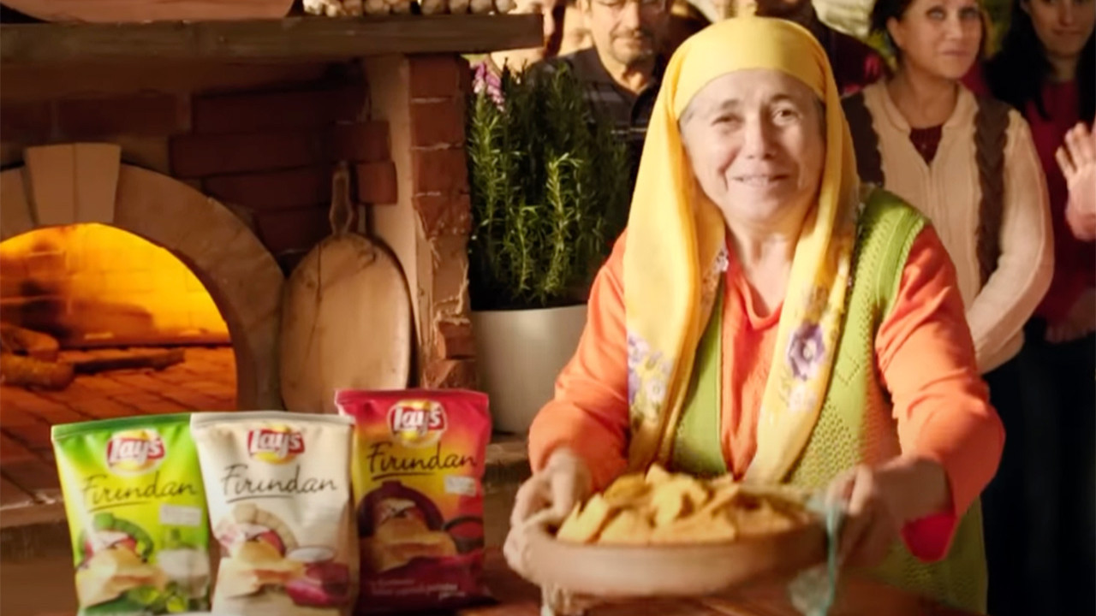
Target Audience
- Demographics: Ages 5-35, from children to adults, regardless of income group. The primary focus is on youth and families engaging in group activities like watching matches or going on picnics.
- Psychographics: "Experience-oriented" consumers who seek products to accompany pleasant moments, are open to sharing, value local flavors, and are active in the digital world.
Market Positioning
- Competitors: Pringles (Premium segment), Doritos (Youth/Bold segment), local chip brands.
- Differentiators: Lay’s distinguishes itself through its emphasis on "naturalness from the field," "local production," and a "thin, crispy texture." While Doritos represents fun and Pringles represents status, Lay’s represents sincerity.

Analyzing the Brand Using the 9 Best Practices

1. Authenticity & Transparency
Application: Emphasis on "From Field to Pack" and "Our Potatoes, Our Lay’s."
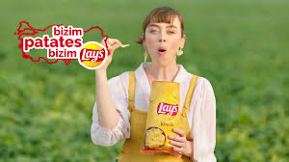
Analysis: Lay’s builds trust by showing that the product is not merely manufactured but produced by real farmers across 18 cities of Turkey using 100% local seeds. The Ayşe Teyze figure serves as the "local and sincere" face of this transparency.
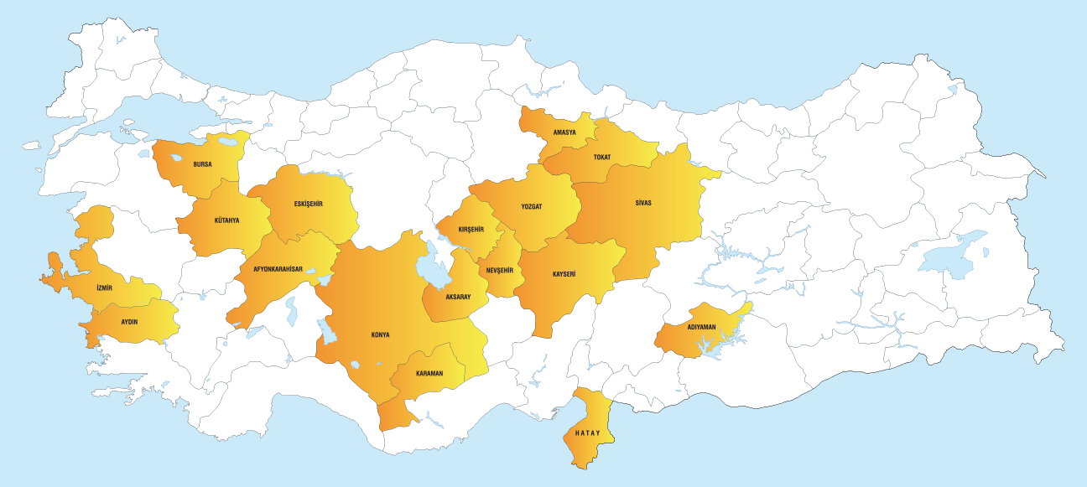
Weaknesses and Growth Opportunities:
  - Transparency Gap in "Factory" Stages: While the emphasis on "field and natural potatoes" is strong in advertisements, the industrial process of the product is almost never featured in digital communication. This creates a "trust gap" and suspicion regarding preservatives and industrial processes among some current and potential consumers.

  - Improvement Suggestion: The brand should transparently share the technological and hygienic processes inside the factory on digital platforms. Content themed "Don't Fear the Factory" could break the perception of "marketing makeup" and provide genuine digital transparency and trust.

2. Consistent, Human Storytelling
Application:
  - A Harvard graduate returning to his land to farm.
  - A producer feeling proud while looking at a Lay’s bag on a market shelf, saying, "Our potatoes!"
  - During the pandemic, Demet Evgar reaching consumers with natural and sincere videos filmed at her own home instead of professional sets.

Analysis: The brand tells the human story and labor behind the chip, not just the product itself. These narratives position the brand as "one of us" and a "humane brand that adapts to conditions."
Weakness and Growth Opportunity:
- Weakness: Narrative limited to the "Field." The brand story focuses heavily on the field and harvesting stages. Omitting the factory and processing stages that occur between the field and the bag creates a gap in the consumer's mind regarding the transparency of the process.
- Growth Opportunity: "The Journey of a Potato" Commercial: The brand can film an integrated story characterizing the chip as a product meeting its buyer, covering every stage from planting and harvesting to factory shipment, hygienic processing, and finally reaching the shelf. This "end-to-end" narrative would maximize trust by presenting the entire supply chain in a humane and transparent language.

3. Customer-Centric Approach
Application: "New Lay’s Flavors" campaign in Turkey (Ayvalık Toast, İzmir Tulum Cheese, Kebab, Mıhlama) or "India’s Magic Masala" flavored chips in India and Sponsoring the UEFA Champions League in Europe, Cricket in India and Pakistan, and the Super Bowl in the USA.
Analysis: As a global giant, Lay’s focuses on local tastes and cultural passions (Glocal strategy), sending the message: "I produce what you want and I am where your heart beats." By aligning its digital and physical presence with the most popular sports and flavors of each specific region, Lay’s places the customer’s local identity at the center of its global brand identity.
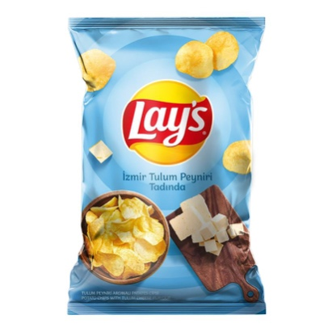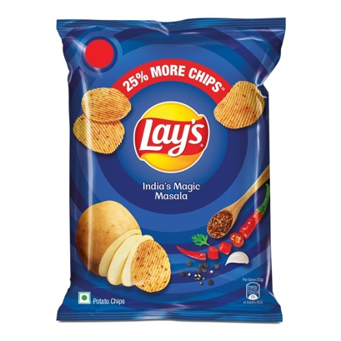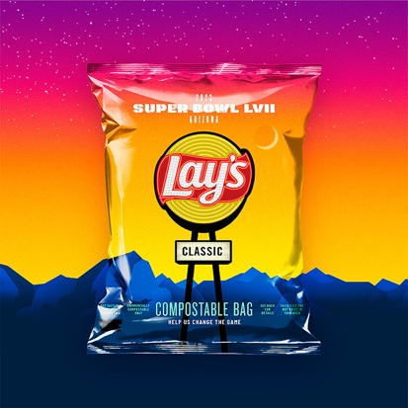

4. Platform-Native Content

Application:
- TikTok Concept: Posting short-form videos fitting current trends or starting a movement with a Messi filter asking, "What is your favorite Lay’s chip?"
- YouTube Concept: Producing long-form, entertaining culinary content with Danilo Zanna and Demet Evgar under the "In the Kitchen" concept.
Analysis: Lay’s develops content tailored to the spirit of each platform rather than "one-size-fits-all" content. By creating trends on TikTok, it targets Gen Z engagement; on YouTube, it provides educational-entertainment style content that builds deeper bonds. This ensures the ad is an "experience" aligned with the user's purpose on that platform rather than an "interruption."
Weakness: Some videos produced for YouTube can occasionally feel like a "marketing-heavy" intervention.
Growth Opportunity: Platform-specific series production. Instead of making Lay’s the subject of every video (as in "Lay’s in the Kitchen"), creating a program like "Lay’s Talk" where celebrities chat and Lay’s is a supporting element could create a more sincere atmosphere.

5. Responsible Data Use & Personalization
Application: Messi Messages (#LaysUnited): A personalized campaign using AI where Messi sends video messages to names entered by users.
Privacy Protocol: Encrypting data with SSL and enforcing a rule against collecting data from children under 13.
Analysis: While transforming AI into a personalized experience, Lay’s maintains an ethical stance by protecting children's data in the digital age.
Weakness: Some old personalized campaign sites (e.g., Messi Messages) are no longer active.
Growth Opportunity: Offering users a "quick destruction confirmation" stating that data will be deleted once the campaign ends.

6. Two-Way Engagement
Application: "Which one should stay on the shelf?" voting and Brand’s active engagement and real-time replies to user comments under high-traffic videos.
Analysis: The consumer transforms from a passive recipient to a partner steering the brand's production process. While voting campaigns move this interaction to the digital realm, real-time responses to high-traffic videos further humanize the brand. By engaging in direct conversation within the comments, Lay's proves it is not just a logo but a community-driven brand that actively listens to its followers.
https://raftakimkalsin.com/

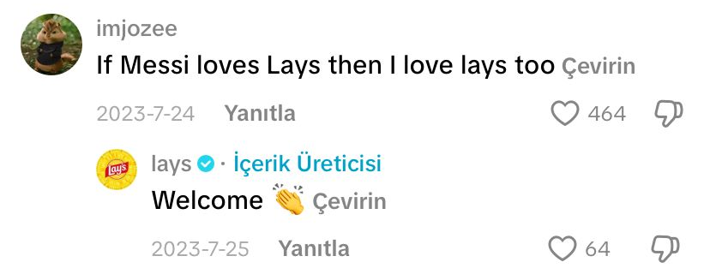

7. Omnichannel Consistency
Application: 360-Degree Sports Experience: Within the scope of Champions League sponsorship, physical stadium boards, the Messi figure in TV ads, and interactive social media content all complement each other with the same visual language and "Match Joy" slogan.
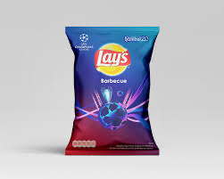

Physical-Digital Bridge: QR codes on market shelves allow consumers to instantly join digital contests/voting.
Analysis: Lay’s offers an integrated experience by making different channels "talk" to each other. The consumer encounters the same brand journey at every touchpoint—stadium, phone screen, or market shelf.

8. Employee Advocacy
Application: Training provided to farmers and advertisements filmed in the fields.
Analysis: Farmers producing for Lay's are positioned not just as suppliers but as the brand's biggest advocates. The sentiment "When we are mentioned, Lay’s comes to mind; when Lay’s is mentioned, we come to mind" reinforces this sense of belonging.

9. Digital Reputation Management
Application: The #ToprağaKüsmekOlmaz (Don't Give Up on the Land) and "Joint Action, Renewed Abundance" campaigns following the February 6 earthquake, in collaboration with Needs Map (İhtiyaç Haritası).
Analysis: Providing 13,000 square meters of agricultural support, free training, economic aid, and scholarships for university students converts the brand's stance during social crises into a positive digital reputation.

3. Recommendations
- "The Journey of a Potato" and "Don't Fear the Factory" Commercial: Create a film that characterizes the potato's journey from planting to the final shipment. This end-to-end transparency will humanize the entire supply chain.

- "Lay’s Talk" Concept: Shift from making the product the center of attention to making it a natural part of an entertaining celebrity talk show format to foster a more sincere environment.

Link to Final Project
- Brand Promise: "With its natural flavor coming from the field, Lay’s is the companion to the most sincere moments shared in every pack."
- Campaign Goal for Final Project: To significantly increase the perception of brand transparency through digital channels in order to address consumer doubts regarding 'healthy production.

Resources:
Tam da Layslik Reklamı:
https://youtu.be/xafzXHZwCo0?si=cbG1fAOuY_L1pU0-

Gurmeoğulları ve Esnafoğulları Kapışması Reklamı:

https://youtu.be/3Jh46oe218A?si=GPY352Ku7jZhmu1p

Gurmeoğulları ve Esnafoğulları kapışması rafta hangisi kalsın reklamları:

https://youtu.be/yzAWo_MwkaI?si=yuJyizgV4rlHWcpr

https://youtu.be/9GEHWXP2Eb0?si=PbKAC7zsBsFxArkB

Lays Fırından Mezuniyet telaşı Reklamı:

https://youtu.be/DlfkKJe0o_c?si=0FVSzQj9d3mp_lMT

#ToprağaKüsmekOlmaz Reklamı:

https://youtu.be/DMGiVz4m1nQ?si=16pwuxHm5kBy2Bwb

Ortak Hareket Yeniden Bereket Reklamı:

https://youtu.be/_p4mEcPzELY?si=-802ZqtFULMuccDQ

Lay’s Çıtırtısı Bizim Çiftçilerimiz Bizim Topraklarımızdan Reklamı:

https://youtu.be/RgAG0a0WPmM?si=glqxJhNxEgog6DXn

Lay's ve İhtiyaç Haritası İş Birliği Reklamı:

https://youtu.be/QbXOCxsodBI?si=EyCrCS54einbLA64

Sen de Fotoğrafını Paylaş, Lay's ile Paylaş Bir Gülümseme! Reklamı:

https://youtu.be/DInJj49tXM0?si=FXyEoyX6tlMpvrcd

Yeni Lay’s: Kaşar Peyniri & Izgara Soğan Tadında! Reklamı:

https://youtu.be/mduZewVdT_M?si=0iCkHs8-zrz3Gnoa

Çiftçilerimizin Umudu: Lay’s 🥔 Reklamı:

https://youtu.be/G2Rzm-x6bgM?si=zVXE0C5V2Warlygh
Çiftçilerimizin Gururu: Lay’s 🥔 Reklamı:

https://youtu.be/d3Hi3x6dQBE?si=sgThcPGt8Qj6PFU5

Çiftçilerimizin Memnuniyet Sebebi: Lay’s 🥔 Reklamı:

https://youtu.be/fZxcVV9N2J0?si=paIN3IFl1jtJ99rr

Lay’s ile Tarladan Pakete – Harvard’dan Çiftçiliğe Uzanan Yolculuk Reklamı:

https://youtu.be/nk4FpUzHGz0?si=9wbhsNiAMcdrwvBR

Lay’s ile Tarladan Pakete – Çiftçilik Onlarda Baba Mesleği Reklamı:

https://youtu.be/swRPRSpg0gU?si=0df5G1C6UubRLVW-

Bizim Patates, Bizim Lay’s 💛 Reklamı:

https://youtu.be/a0Py91wh2dE?si=9f0-inDKrSmT0NmC

Tarlalar Farklı Olsa Da Lezzet Hep Aynı Reklamı:

https://youtu.be/bnd4DKGWB1U?si=OkgCu45GeDYjWZJP

Türkiye’nin Topraklarından ve Çiftçilerinden: Lay’s Reklamı:

https://youtu.be/p_rzJhpSxTI?si=XlumBElcg2z-huvc

Demet Evgar ile Evde Lay’s Reklam Çekimi 5!:

https://youtu.be/6wWVGZBy4oY?si=cHZxGZOtZkYzvZ53

Lay's ile Baharın En Çıtır Etkinliği | Maçka Parkı 🌸 Reklamı:

https://youtu.be/BdbZLult-MY?si=bav3LR-N-eWNZD-Z

İzmir Tulum Peyniri Tadında Lay’s ile Yaz Çıtırında! ☀️ Reklamı:

https://youtu.be/4TJETTMm-g8?si=25I1iHugTeubDyE1

Yeni Lay's Tatları Yakında! Reklamı:

https://youtu.be/0KaWcScW9pI?si=RGlsxBwtAnFOE3v8

Yeni Lay’s’imiz Tulum Peyniri Tadında Olsun Mu? Reklamı:

https://youtu.be/hCjWVRJbn8k?si=c6iXHMwOqmdcrtWh

Yeni Lay‘s’imiz Kebap Tadında Olsun Mu? Reklamı:

https://youtu.be/MGMjg_Mi3VE?si=jc-87gEe6lsxWKPT

Yeni Lay’s’imiz Mıhlama Tadında Olsun Mu? Reklamı:

https://youtu.be/xcHAVjTjvME?si=bBkjZ1GZYRB_bb3A

Yeni Lay’s’imiz Ayvalık Tostu Tadında Olsun Mu? Reklamı:

https://youtu.be/-GJh_h2qjVw?si=p9UpPO7fc9xF8l0g

Yeni Lay’s’imiz Mantı Tadında Olsun Mu? Reklamı:

https://youtu.be/XRc6lkvTsmI?si=dLg_hTGD5WMHKv5m

Yeni Lay’s’imiz Döner Tadında Olsun Mu? Reklamı:

https://youtu.be/98z7aEx0oX4?si=sOvwkOhB5Csq6dsq

Dünyadaki 100 Lay's Çeşidini Oyla, Yazın Tadını Keşfet Reklamı:

https://youtu.be/arB1q11n3JI?si=tO5jCGgCkepOZT5l

Lay's ile Futbol Keyfini İkiye Katla! 🏆 Reklamı:

https://youtu.be/3zroSOtsEpU?si=eIU4cY4FFhcGMu-t

Yazın Tadı Lay's ile Çıkar! Reklamı:

https://youtu.be/A4qfnJPtkt0?si=DNKpalzapVJMrpQr

#MaçaHazırmısın Reklamı:

https://youtu.be/ygZuArm03Ns?si=6T3yUJpdEpj8g4xh

Refika ve Burcu Esmersoy Lay's Fırından Lezzetler'i Deniyor Reklamı:

https://youtu.be/D0amMlcviW0?si=2kwncwE0T7IwhGWj

Ayşe Teyze Patatesi Reklamı:

https://youtu.be/yOLb2sCJNXQ?si=XNLEq_FS7pPPcp-B

Lays Kaşık Cips Reklamı:

https://youtu.be/Z9X1iqNBcqM?si=2n0C3eyfg9A0xizN

Ayşe Teyze'li Lay's Reklam Filmi:

https://youtu.be/zn7QHBzRTAo?si=hrMYOIrKwhXml7s2

Ayşe Teyze'li Lays İsotlu Cips Reklamı:

https://youtu.be/dhU2IYhyK84?si=-7K1brS97PkcGpkq

Lay's Yoğurt ve Mevsim Yeşillikleri Çeşnili Reklamı:

https://youtu.be/uEI9AzVvjVc?si=s1FgYAonWj46Do0p
Messi Visits Reklamı:

https://youtu.be/OEUB49kmbH0?si=9mKspUFdycb8XY6y

Lay's Messi ve Ayşe Teyze Reklamı:

https://youtu.be/0doXeCYm0M4?si=0bs1xp6O8CFDEONA

Lays Messi Oh Lays 2024 Commercial Reklamı:

https://youtu.be/VcSuJBwmsWI?si=7xGyLtKqSyHAHRyA

#NoLaysNoGame Bar Crawl with Leo Messi, Luis Suarez, Alexa Putellas and Thierry Henry:

https://youtu.be/23lhUYnnnBk?si=2mBJyuDSyprphQTK

Lay's I Messi Messages #LaysUnited :

https://youtu.be/mwWtxF7wKvQ?si=h94-cWxIqD9YIpQQ

Mesaj Messi

https://youtube.com/shorts/dmUKvCG_oxA?si=S_JdVVI4udvEx7qU

America's Favorite Chip. Since 1938. Reklamı:

https://youtu.be/j6MLpuACZ5s?si=biQrcSy9s0wFbfCz

Lays Pakistan-Kriket Reklamı:

https://youtu.be/L_d8fFUM_8s?si=NJFdsjMdKQWpZ3Me

Recycle with Lay’s:

https://youtu.be/M9isXqLGSzs?si=wc90P7EGFusc3buD

Lays India Reklamı:

https://youtu.be/LKBuzYQRjjs?si=jHuW_MqJXukZWNKQ

Lay’s Mutfakta Youtube:

https://youtu.be/vgbKJJjgLdA?si=4FMkk4gRz5nhJ8K9

Lay’s Tiktok Content:

https://www.tiktok.com/@lays/video/7606110882640235789

https://www.tiktok.com/@lays/video/7580806114002996493

Lay’s Farmer Heritage:

https://www.lays.com.tr/pozitif-tarim

Lay’s (PepsiCo) Privacy Policy:

https://www.pepsico.com.tr/gizlilik-politikas%c4%b1

Which one should stay on the shelf voting:

https://raftakimkalsin.com/

